FAMILIES: Please read and complete the survey at the end of this page

Dear Eagle Staff Orchestra Family,
Welcome to the 2023-24 school year! My name is Hannah Gorham, and I am so excited to begin this year with your students. In addition to directing the orchestras, I also teach the semester-long guitar and experience music courses. My commitment to you is maintaining an orchestra program that centers on student joy, hope, and celebration of success. I believe deeply in every student’s assets, creativity, and intelligence and I strive to make orchestra a place where they can foster and showcase that.
WELCOME LETTER

The purpose of this Student Handbook is to provide students and families with the information necessary to navigate through the school year. If there are ever changes to this information, I will communicate directly with you!

As a member of orchestra, and of the music department in general, students will be exposed to opportunities and experiences that will lead to a positive, safe, and successful time in the program and at the school. This may include local and out-of-state trips, student leadership opportunities, partnerships with local organizations, and the playing a variety of genres of music.

While the traditional instruments of orchestra are violin, viola, cello, and bass, if your student already plays a secondary or different instrument that isn’t always included in a school ensemble (piano, harp) and would still like to be a part of orchestra, please let me know! It is possible we can work that into our ensemble, as my main priority is creating a space where all students belong.

Thank you for being a part of orchestra this year!
CONTACT ME + SURVEY
If you have any questions at any point this year, please contact me and I am happy to chat!
My email address is hrgorham@seattleschools.org

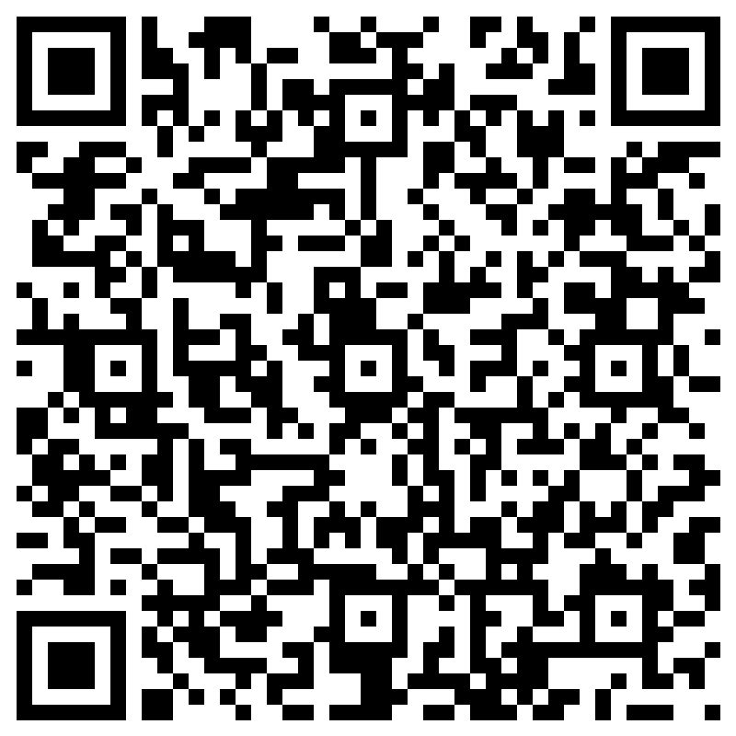
Make sure you have completed the family survey (QR code and link below). This helps me keep track of the best way to contact your family, as I understand different families have different preferences.
Or, type this link into your browser: https://tinyurl.com/gorhamsurvey

MATERIALS and EXPECTATIONS

REQUIRED MATERIALS:
- Instrument & Accessories for instrument care
  - Violins and violas should have an instrument that includes a shoulder rest- if you need help acquiring one, please tell Ms. Gorham!
  - Cellos and basses should have a rock stop for their endpin. We have them available at the school for class and concert use, but it would be helpful to have one at home!
  - All instruments should have a soft cloth for cleaning and bow rosin – again, if you need help getting any materials, please let Ms. Gorham know
- Music folder that includes all sheet music and handouts given throughout the school year. One will be provided but you are welcome to use your own.
- Writing utensil (pencil, pen, etc.) – this should be brought to class every day.
- School-provided laptop device and charger

Method Books:
If you are able to purchase a method book, I ask that you do! If your student would like to use a school copy, we will have them available.
Students can purchase the following books at the stores listed above or online. :
- Premier Orchestra: String Basics Book 1 (RED and some blue cover)

- Intermediate Orchestra: String Basics Book 2 (BLUE and more bluw color)

- Concert Orchestra: Essential Techniques Book 3 (Green) – NOT STRING BASICS
NOTE: When purchasing method books, please make sure that you choose the book for the instrument that your student plays. The instrument version is indicated at the top of the book.

BEHAVIORAL EXPECTATIONS (Aligned with SOAR) – SCHOLARS PRIORITIZE:
- Safety
- Ownership
- Achievement
- Resilience

PERFORMANCES:
Participation in performances is a requirement for orchestra, as they serve as the summation of students’ learning. Not only is it a part of the students’ grades, but attendance at these performances particularly influence the sound and camaraderie of the group. If students will need to miss performances, please follow the stated protocol below:

- Students must provide a two weeks’ notice of said absence prior to the performance to receive an alternative assignment. Absences that will be considered excused are, but not limited to, medical and family emergencies, school-sanctioned sports or clubs, and/or religious engagements. If it is impossible to give two weeks’ notice, families should communicate with me as soon as able and we will work out an alternative graded assignment.
The following outlines the graded performances for the year. If other performance opportunities arise, such as a local organization partnership, fundraising opportunity, or in-school concert, students will be asked to perform as they are able but they will not be graded.
CONCERT SCHEDULE
Unless listed, all performances involve all orchestras (premier, intermediate, and concert).

NOVEMBER
- Performance With Ballard HS and Alternative Styles Expert Christian Howe
  - ONLY INTERMEDIATE AND CONCERT ORCHESTRAS
  - Wednesday 11/8 at 7pm, following an all day field trip to Ballard HS

DECEMBER
- Winter Concert
  - All orchestras + Semester 1 guitar class
  - Tuesday 12/05 @ 7PM

MARCH
- Tentative: Central Washington University Orchestra Festival (All Day Field Trip)
  - CONCERT ORCHESTRA ONLY
  - Friday March 8
  - More details will be provided early in the school year

- Spring Concert
  - All orchestras
  - Tuesday, 03/26 @ 7PM

JUNE
- End Of The Year Concert
  - All orchestras + Semester 2 guitar class
  - 06/11 @ 7PM
Other performance dates for optional performances will be announced as they come up

Grading for all music classes will be aligned to the school’s Standards-Based Grading system. Listed below is the divisions of grading for each ensemble, as well as the language used in the Standards-Based Grading:
GRADING
LEVEL OF RUBRIC | MARK IN GRADE BOOK
Exceeding Standard (“I can do this on my own and help someone else do it”) | L4
Meeting Standard (“I can do this on my own”) | L3
Approaching Standard (“I can partially do this on my own but require some help”) | L2
Just Starting (“I’m still working on understanding this”) | L1

REDO/LATE WORK POLICY:
For written assignments and projects, students can submit their missing or incomplete work up until the last day of the given quarter without any penalty. In fact, resubmitting or retrying work is highly encouraged in my classes. Grading in music is grading on progress, and application of skills, not perfection. By retrying an assignment, playing test, or other project component, students demonstrate the valuable skill of goal setting, assessing their improvement, and reflecting on their learning.

Students who are in need of borrowing school instruments will be able to do so for free from the school inventory, with approval from the Director and completion of the Instrument Rental Form.
INSTRUMENT LOANING
Students wishing to purchase or rent their own instruments can do so with local instrumental music vendors. Listed below are a few, but not limited to, options within a 20-mile radius of the school. Please feel free to explore purchasing instruments and supplies at other music vendors as well:
AMERICAN MUSIC | KENNELLY KEYS | METROPOLITAN MUSIC | MUSIC & ARTS | TED BROWN
4450 Fremont Ave N | 4918 196th St SW | 8414 5th Ave NE | 10120 Main St | 1006 NE 50th St
Seattle, WA  98103 | Lynnwood, WA 98036 | Seattle, WA  98115 | Bothell, WA  98011 | Seattle, WA  98105
(206) 633-1774 | (425) 771-7020 | (206) 729-9299 | (425) 486-5000 | (206) 622-0171

In order to help meet some of our financial needs, we are requesting a $40 program fee to those who can help provide financial assistance for the music program’s operations costs. Please note that paying the activity fee is NOT mandatory and will NOT have a negative effect on your student’s participation in music.
The following are the anticipated costs associated with the orchestra’s operations and events/performances for this year. Please note that the Director and FORESMA are committed to working with families to ensure that EACH and EVERY students who is interested in participating in all activities are able to do so, regardless of each family’s financial situation. your family anticipates a difficulty in covering the expenses for your student, please contact me directly.
PROGRAM FEE

The activity fee donation provides aid for the following:

- Sheet music for the Bands and Orchestras
- Instrument purchases and repairs
- Transportation to local and overnight activities
- Financial assistance/scholar-ships for students
- Festival fee performance supplements
- Specialized private instructors and guest clinicians

You can pay this fee in a couple ways:

  - Paying by credit card? Go to www.Foresma.Org and click on the button to pay your fee
  - Paying by check? Make checks out to “FORESMA” and mail to:
FORESMA c/o Robert Eagle Staff Middle School,
1330 N 90th St, Seattle, WA 98103

The Friends of Robert Eagle Staff Musical Arts (FORESMA) is a booster group of dedicated parents and guardians who help support and sustain the Bands and Orchestras. FORESMA’s mission is to ensure access to music education for all interested RESMS students by raising funds, volunteering, and providing logistical support to the RESMS music directors. FORESMA’s most important resource is its community of families and friends – your interest and participation are welcome and needed! FORESMA meets on the second Monday of every month at 7PM in either the Band Room or Orchestra Room (virtually during the remote learning phase).
FORESMA

Listed below are some ways that families can get involved with FORESMA:
- Visit www.foresma.org for information and up-to-date announcements regarding the RESMS Music programs.

- Interested in being a part of the leadership team? Board Positions include President, Vice-President, Secretary, as well as multiple Chair and Coordinator heads (fundraising, communication, Trip Coordinator, etc.). Please inform one of the current Board Members if you are interested in serving in one of the positions.

- Information will be forthcoming from FORESMA about how and when to pay the Activity Fee. Please visit https://www.foresma.org for up to date information on payment.

- If you have an unused instrument in good working condition, please consider making an in-kind donation so we can loan it to our students in need.

- Whatever you have to give, we welcome your help in building a strong parental booster community for the Eagle Staff Music Program. If you would like to get involved and volunteer, please email any questions and suggestions to info@foresma.org or volunteer@foresma.org

